ML Forecasting Emission and EQE Limits in Quasi-2D Perovskites
Ranadeep Raj Sumukam, Ramu Naidu Savu, Santhosh Rompivalasa and Banavoth Murali*
Solar Cells and Photonics Research Laboratory, School of Chemistry, University of Hyderabad, Prof. C R Rao Road, Hyderabad -500046, Telangana State, India.
*Email: murali.banavoth@uohyd.ac.in
ABSTRACT
Layered quasi-two-dimensional metal-halide perovskites (quasi-2D MHPs) have captivated researchers in the field of light-emitting diodes (LEDs) owing to their facile solution-processing and highly tunable optoelectronic properties. Compared with other dimensional perovskite counterparts, quasi-2D MHPs offer more tuning parameters, providing a wider scope for control and making them more complex systems. Therefore, exploring their vast compositional parameter space remains a major experimental challenge. Machine learning (ML) has emerged as a powerful paradigm for understanding patterns in complex systems. In recent times, ML has been used extensively across all fields to accelerate research and reduce costs by strategising work rather than relying on trial-and-error experimentation. In this work, we developed two distinct sets of hyperparameter-tuned ML models using data compiled from the literature, where the first set is focused on material-level intrinsic emission energy prediction and the second one is on device-level external quantum efficiency (EQE) prediction. Among all models, the Support Vector Regression model with a radial basis function kernel (SVR–RBF) achieved an outstanding coefficient of determination (R²) of 0.953 and a low root-mean-square error (RMSE) of 0.074 eV with the emission energy prediction window covering a major part of the visible spectrum. In contrast, predicting device EQE resulted in an R² of only 0.57 at best. Thereafter, model decisions were thoroughly validated using Kernel SHAP analysis. Finally, to facilitate adoption by the research community, the final models are deployed as an interactive, publicly accessible Streamlit application that enables real-time emission energy prediction based on spacer chemistry and precursor ratios.
TOC Graphic
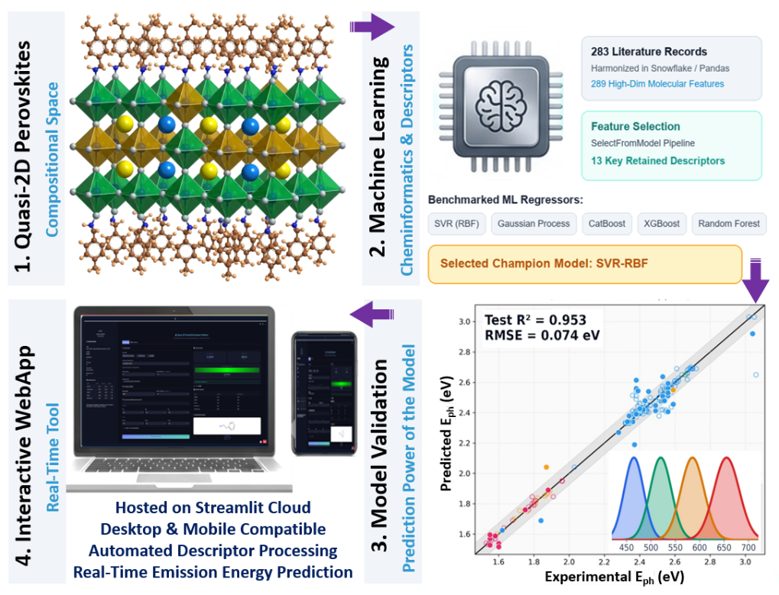

1. Introduction
Metal halide perovskites (MHPs) have attracted attention in optoelectronics for their exceptional absorption coefficients, tunable band gaps, high colour purity, and solution processability, enabling rapid progress in solar cells, photodetectors, lasers, and light-emitting diodes (LEDs).¹⁻⁵ Among low-dimensional variants, layered quasi-two-dimensional metal-halide perovskites (quasi-2D MHPs) have emerged as a versatile class of materials for perovskite LEDs (PeLEDs).⁶⁻¹⁰ Structurally, quasi-2D MHPs are formed by intercalating bulky organic spacer cations into the 3D framework, which slices the inorganic octahedra into layers of thickness n. These quasi-2D MHPs are primarily categorized into Ruddlesden–Popper (RP) phases with the general formula L₂A_{n-1}Pb_{n}X_{3n+1} (A = small organic cation or inorganic cation, X = halide ion) where monovalent spacer cations (L) form van der waals gaps between the inorganic layers and Dion–Jacobson (DJ) phases with general formula L′A_{n-1}Pb_{n}X_{3n+1} where divalent diammonium cations (L′) bond directly to adjacent inorganic sheets eliminating the van der Waals gap. By tuning their quantum and dielectric confinements through organic spacer chemistry and halide composition, we can cover a broad portion of the visible spectrum while retaining solution processability and improved environmental stability compared with their three-dimensional counterparts.^{5, 11}
Since the parameter space is large in quasi-2D MHPs, unlike in their 3D counterparts, their outcomes are not always predictable from the main stoichiometry alone. Research groups struggle to explore this space experimentally because they can only vary one variable at a time. Traditional materials development for perovskite optoelectronics has always depended on trial-and-error experimentation, density functional theory (DFT) and high-throughput screening. Now, Machine Learning (ML), which relies on statistical models, has emerged as a complementary fourth paradigm that can learn patterns from curated datasets, reduce experimental waste, and, unlike physical models such as DFT, ML is not constrained by predefined theoretical rules, which enlarges the scope for finding new relations and empirical laws. Therefore, ML models have been adopted in perovskite photovoltaics and, more recently, in LED work, to extract patterns from curated datasets.¹²⁻¹⁷
Materials-focused ML workflows typically comprise data collection, data cleaning, feature engineering (molecular descriptor generation, correlation filtering, and feature selection), model training, and performance evaluation, along with insights from interpretability tools such as SHAP (Shapley Additive exPlanations) to connect predictions with physicochemical mechanisms.¹⁷⁻²⁰ To date, there are very few ML-based reports focused on quasi-2D MHPs and LEDs. Prior work on quasi-2D MHPs demonstrated that photon energy can be estimated from precursor composition and lipophilicity (XLogP3) of organic ligand, leveraging a random-forest model with root-mean-square errors on the order of ~0.05 eV.²¹ Work on predicting PeLED performance with respect to the change in additives achieved good accuracy when the dataset was built from a single device architecture.²² However, all the studies are confined to a narrow spectral window (for example, green or blue Br/Cl systems) and a very limited feature set based solely on precursor ion ratios with single organic ligand systems without explicit encoding of their structures using cheminformatics descriptors. In addition, none of the previous works has built a web user interface (UI) application that could be utilised in real time for researchers. Considering these gaps in prior work, we developed a set of ML models to identify the appropriate chemical components and their relative concentrations for preparing the desired quasi-2D MHPs. The models built have the scope to predict emission energy across the full visible range, which could help in preparing a specific quasi-2D MHPs based on the requirement. Thereafter, a web UI application is built using Streamlit Cloud, leveraging the best-performing models to enable real-time utilisation. In addition, we also tried to answer whether external quantum efficiency (EQE) can be predicted with comparable confidence to the literature data available under the same curation rules as emission energy prediction models.
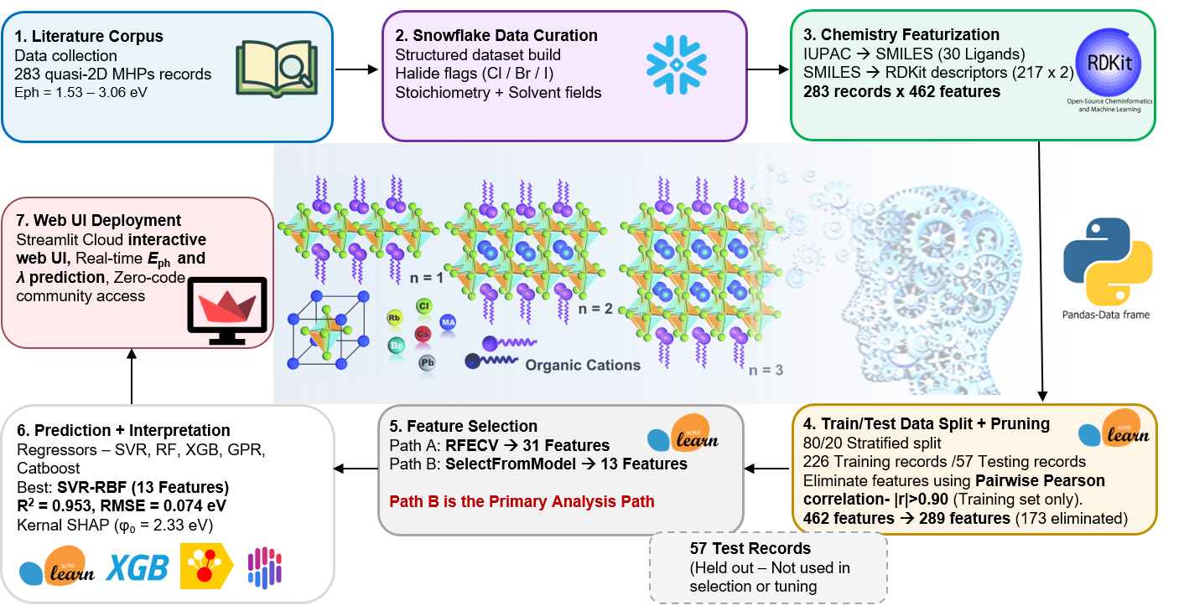
Figure 1: End-to-end workflow from literature extraction to predicted E_{ph}. SMILES conversion, descriptor calculation, correlation pruning, parallel RFECV (31 features) and SelectFromModel (13 features) for feature selection, hyperparameter-tuned regressors, SHAP analysis, and deploying the champion model in the Streamlit Cloud for community usage.
In this work, we built ML models that address the aforementioned gaps, leveraging a dataset of quasi-2D MHPs extracted from the literature for training and testing. Herein, we built two primary sets of ML models: one targeting emission energy (E_{ph}) prediction, which is a material’s intrinsic properties, and the other targeting EQE, which is a device-based metric. After preparing the first version of the dataset, we performed initial cleanup and harmonisation in the Snowflake data warehouse using Structured Query Language (SQL), such as including halide flags, precursor-ratio normalisation, and mixed-spacer indicators. Datasets are available on the GitHub account for reference. On top of the second version dataset obtained from Snowflake, the remaining data engineering operations were performed in Python (Jupyter Notebook) using the pandas dataframes. Thereafter, Simplified Molecular Input Line Entry System (SMILES) strings were generated programmatically for each organic ligand from their IUPAC names using the Chemical Identifier Resolver API hosted by the National Cancer Institute Computer-Aided Drug Design Group (nih.gov). Then, two-dimensional molecular descriptors per spacer (Primary and secondary) were generated using RDKit library with the help of SMILES. After generating molecular descriptors, high-dimensional feature extraction yielded a dataset with more features than the number of observations, leading to the curse of dimensionality. So, to handle the curse of dimensionality, we applied a couple of feature elimination techniques in a sequential order: 1) Pairwise Pearson correlation and 2a) SelectFromModel for one set of models and 2b) Recursive Feature Elimination using Cross Validation (RFECV) for another set of models. After model training and evaluation, we further performed an in-depth SHAP analysis. Figure 1 gives the holistic view of the workflow. Finally, a web UI application is built in Streamlit Cloud so that users can input the required values and get the corresponding emission energy values with the figures showing the structures of organic spacers given in the input. The complete codebase for building various models and a web UI application, along with the datasets used, is available on GitHub.
2. Results and Discussion
2.1. ML Models for Emission Energy Prediction
To target emission energy prediction, we prepared a curated dataset of 283 records for ML model training and testing, extracted from the available literature (dataset available on GitHub: SF_DATA_EMISSION_PEAK.xlsx, sheet SF_DATA_EMISSION_PEAK_NEW; Dataset Statistics are provided in Table S1-S3). In order to construct a generalised machine learning model applicable across a broad spectral range, the training dataset was curated from literature reports covering emission photon energies of 1.53–3.06 eV (wavelengths of 405–810 nm). As expected, the data distribution is uneven, mirroring the available literature to date. Approximately ≈ 69% of 283 records fall between 480 nm and 550 nm (green–yellow), ≈ 12% lie in the violet/blue (400–480 nm), and ≈ 17% in deep red and near-infrared (650–900 nm), with fewer orange/red points in between (Table S2). A model trained only on typical green emission perovskite materials would underrepresent the halide and confinement extremes, thereby limits the scope to that wavelength range itself.
Figure 2: a) Correlation heatmap and b) feature importance scores for the 31 retained training features by the RFECV technique.
For the features, after generating two-dimensional molecular descriptors using SMILES as mentioned in the section above, the dataset had 462 columns, including compositional and halide flags, one-hot-encoded solvent columns, and Pri/Sec-prefixed RDKit descriptors for organic spacers (217 descriptors each). To maintain proper data distribution across reports with mixed organic spacers and single organic spacers, in which 46 entries (~16%) have mixed primary and secondary spacers, we used an 80/20 split stratified by the IS_MIXED_SPACERS_SPACER column, yielding 226 training and 57 test records. It is worth noting that mixed spacer formulations are chemically significant, as the secondary ligand prominently affects interlayer spacing and can determine which n domains contribute more to the emission. After splitting the dataset into training and test sets, we began feature elimination to prevent the curse of dimensionality using only the training dataset, to avoid test data leakage. To reduce feature dimensionality, a pairwise Pearson correlation filter was first applied to the training fold. Features exhibiting a correlation coefficient of |r| > 0.90 were deemed redundant, resulting in the removal of 173 columns and leaving 289 candidate features. Using these 289 remaining features, we evaluated two independent feature selection strategies in parallel on the 226 training records: Recursive Feature Elimination with Cross-Validation (RFECV) and tree-based SelectFromModel. The RFECV approach utilized a Random Forest regressor (max_depth=5, min_samples_leaf=6) evaluated over a 5-fold stratified cross-validation. In this approach, features are removed one at a time until the cross-validated root mean square error (RMSE) of E_{ph} reaches a minimum. According to RFECV, the curve in Figure S1 indicates that 31 of 289 features are optimal, as additional features no longer improve cross-validation. The correlation heatmap and the feature importance scores for the 31 features are shown in Figure 2. On the other hand, the SelectFromModel approach works differently. In this, a single random forest with threshold='mean' was fit on all 289 features, which means it keeps only descriptors whose impurity-based importance exceeds the forest average. Given the aggressive approach, we were left with only 13 features. The correlation heatmap and the feature importance scores for the 13 features are shown in Figure 3.
Figure 3: a) Correlation heatmap and b) feature importance scores for the 13 retained training features by the SelectFromModel technique.
Finally, multiple ML models (Regressors: random forest, CatBoost, XGBoost, Support Vector Regression (SVR), and Gaussian process) were built using the above prepared datasets. Among all the models, the SVR model outperformed the others in predicting emission energies using the dataset from the SelectFromModel approach. It is worth noting that the models built on the datasets using the RFECV technique also performed well. We have summarised all the models' performance in Table 1. Every regressor in Table 1 was tuned by randomised search (15 trials, five-fold cross-validation on the training set) before a single evaluation on the test fold. Tree ensembles can memorise rare spacer–halide combinations in 226 rows, and Gaussian Process Regressors (GPR) are sensitive to kernel length scales when the number of features (p) is large. For the thirty-one-feature RFECV matrix, tuning improved GPR’s coefficient of determination (R²) from 0.877 to 0.920, and in the case of thirteen-feature SelectFromModel matrix, SVR and GPR were improved, out of which SVR with a radial-basis-function kernel (SVR–RBF) emerged as the best, with the R² = 0.953, RMSE = 0.074 and mean absolute error (MAE) = 0.048. Formulas for each evaluation metric are defined below (Equation 1-3), where E is the reported photon energy, Ê is the predicted photon energy by the model, and Ē is the mean of reported photon energies. All the models summaries and the SHAP analysis of the models are available in the supporting information.
$R² = 1 - [ Σᵢ (Eᵢ - Êᵢ)² ] / [ Σᵢ (Eᵢ - Ē)² ]$ – Equation 1
$RMSE = √[ (1/n) · Σᵢ (Eᵢ - Êᵢ)² ]$ – Equation 2
$MAE = (1/n) · Σᵢ |Eᵢ - Êᵢ|$ – Equation 3
To validate the statistical robustness of the champion SVR–RBF model with a limited dataset size (N = 283), 10-fold cross-validation was applied across all available records and bootstrap confidence intervals (n = 500 iterations) were computed on the held-out test set (Figure S2). The 10-fold CV yielded a mean R² = 0.931 ± 0.052 and RMSE = 0.074 ± 0.029 eV, consistent with the single split test set result (R² = 0.953, RMSE = 0.074 eV; 95% bootstrap CI: 0.053–0.091 eV), confirming that the reported performance is not the result of a favourable data split. The predicted-versus-experimental parity plot is shown in Figure 4. Furthermore, the learning curve analysis confirms that the model is well-converged and that the dataset of 283 records is sufficiently large for this feature space (Figure S3). It is crucial to understand that RFECV selects 31 features and achieves a lower training-fold cross-validation error than the 13-feature SelectFromModel channel, yet the 13-variable SVR model is unambiguously better as R² rose from 0.920 to 0.953, and RMSE fell from 0.097 to 0.074 eV, a 24% reduction in root error at less than half the dimensionality. The performance difference between RFECV and SelectFromModel aligns well with the sample-to-feature ratio, which influences overfitting. As shown in Table S4, for 226 training points, the sample-to-feature ratio is 17.4 for the SelectFromModel set but only 7.3 for the RFECV set; therefore, the RFECV flow is more prone to overfitting, which works well on the training data but poorly on the test data.
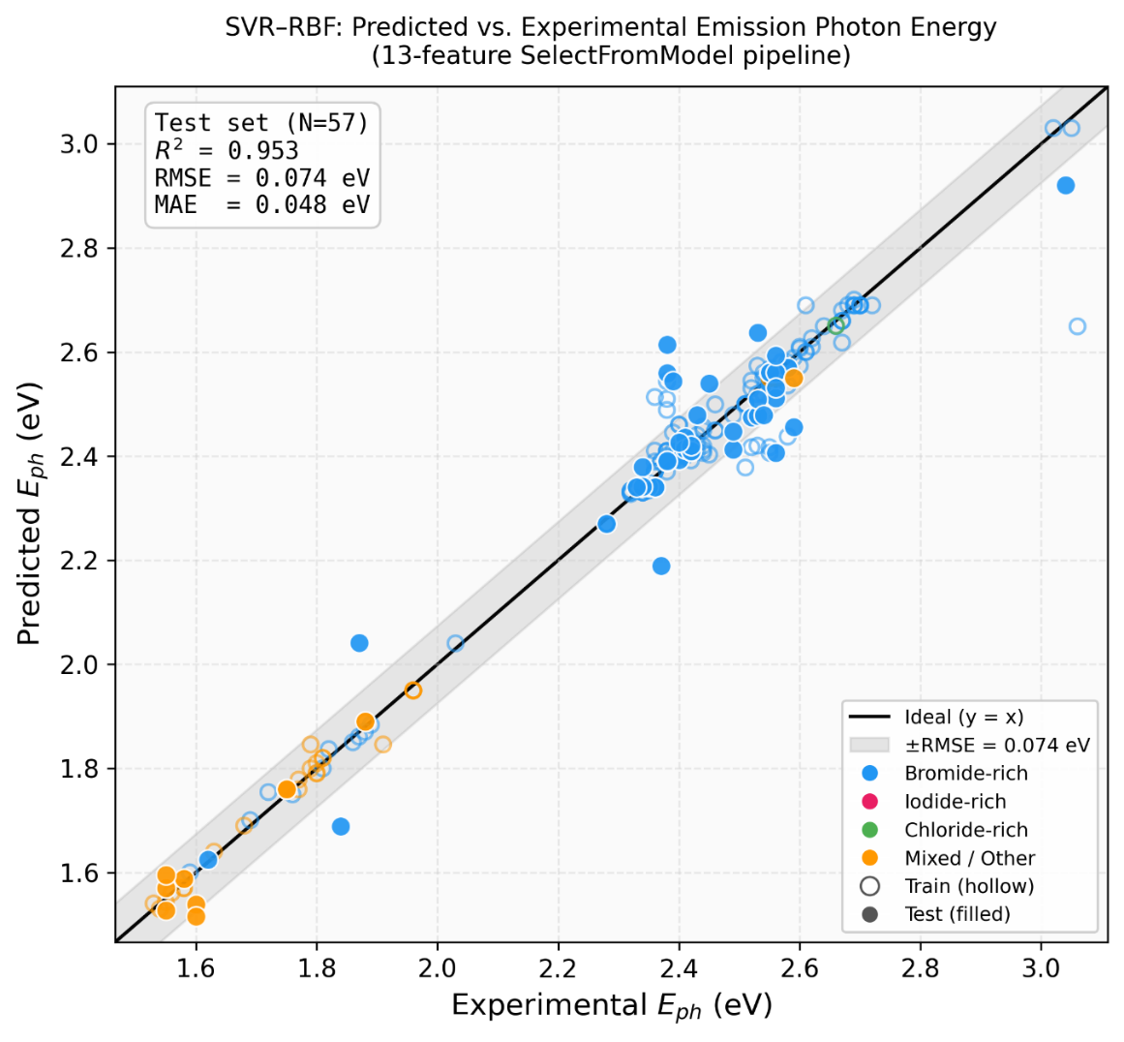
Figure 4. Predicted versus experimental emission photon energy (E_{ph}) for the champion SVR–RBF model (13-feature SelectFromModel pipeline). Hollow circles represent training records (N = 226) and filled circles represent held-out test records (N = 57), colour-coded by dominant halide character. The solid diagonal line represents ideal agreement (y = x) and the grey band indicates the ±RMSE region (0.074 eV).
Table 1. Summary of the hyperparameter-tuned models' performance in predicting the E_{ph}.
Feature selection | No. of features (p) | Model | R² | RMSE (eV) | MAE (eV)
SelectFromModel | 13 | SVR (RBF) | 0.953 | 0.074 | 0.048
SelectFromModel | 13 | Gaussian process | 0.920 | 0.096 | 0.061
SelectFromModel | 13 | CatBoost | 0.875 | 0.121 | 0.063
RFECV | 31 | SVR (RBF) | 0.920 | 0.097 | 0.054
RFECV | 31 | Gaussian process | 0.877 | 0.120 | 0.073
RFECV | 31 | CatBoost | 0.862 | 0.127 | 0.066
Apparently, the SelectFromModel-based features list is short enough to derive scientific insights rather than a black-box vector (full names in Table S5; correlation structure and feature importances in Figure 3). The halide flags that are based on the anion part of salts, sourcing the organic cation (CL_PRIMARY_ORGANIC_HALIDE, BR_PRIMARY_ORGANIC_HALIDE) and the inorganic lead-halide fractions (PbCl₂, PbBr₂) jointly determine the perovskite inorganic framework’s band edge and the halide chemical potential in the perovskite precursor. Bromide-rich precursors generally favour hypsochromic shift, whereas chloride can raise energy further, but often complicates phase purity if not balanced with stoichiometry. On the other hand, iodide-rich recipes promote bathochromic shift. The model selected these features over many unused RDKit columns, indicating a well-established relationship between halide chemistry and emission energy in perovskites.^{5, 12} SPACER_TO_PB_RATIO is a critical parameter that controls the average n (number of layers in the inorganic framework) in quasi-2D MHPs. A greater spacer-to-lead ratio increases the organic fraction in the film, thereby strengthening the average dielectric confinement. It fosters the dominant transition to higher E_{ph} by shifting holistically towards lower n.¹ SPACER_TO_PB_RATIO survival after aggressive selection elimination is perhaps the strongest sanity check on the ML pipeline learning on confinement physics. The A-site cation to Pb ratios (CsBr_TO_Pb, CsI_TO_Pb, FABr_TO_Pb, FAI_TO_Pb) reflect the extent of diversity hidden in the A-site cation data in the prepared dataset. Our model does not assume a single cation; it learned from the blended ratios actually reported. SOLVENT_DMF surviving selection is not surprising as DMF and DMSO are known to change Pb coordination and crystallization kinetics, which in turn changes n partitioning. That variable is a processing fingerprint no less than a compositional one. Among molecular descriptors, Pri_VSA_EState4 (Surface-area + electrotopological-state) captures how much of the primary spacer’s van der Waals surface sits in a particular electronic-state bin, which is related to heteroatom content and polarizability at the organic–inorganic interface. For the 46 mixed-spacer entries, the features that survived elimination are Sec_HallKierAlpha, which refers to the flexibility/topology of the secondary amine and Sec_PEOE_VSA6, which refers to partial-charge surface area on the secondary ligand. They capture how a second ligand perturbs interlayer spacing and local dielectric environment without requiring an explicit n-distribution label.
The 31-variable RFECV set adds a few more features to the list, PRIMARY_SPACER_FRACTION, SOLVENT_DMSO, several Pri_BCUT2D_* partitions, Pri_qed, rotatable-bond counts, and additional PEOE/VSA terms (full list, Table S6). They refined the picture but did not improve the test error, given the available sample size.
2.2. SHAP Analysis
We leveraged SHAP to move from accurate prediction to real-time actionable chemistry by assessing the impact of each feature on the model's behaviour. It provides validation that the fitted SVR ranks drivers in the same order as expected based on chemical mechanisms and confinement physics (Figure 5). For each test record, the SVR prediction is decomposed into the average baseline from background samples(φ₀), which is 2.33 eV from 50 randomly drawn training samples, and the Shapley contributions (φ_{j}) of descriptor j, as shown in Equation 4. A positive φ_{j} pushes the prediction to higher E_{ph} (hypsochromic shift), and a negative φ_{j} pushes it to lower E_{ph} (bathochromic shift). Since SVR is not a tree model, we used Kernel SHAP with the fitted f(x), standardised features, and 50 background samples. Then summarised the rankings across all 283 samples as the mean absolute contribution ⟨|φ_{j}|⟩. We have prepared Table 2, which links these numerical rankings to the photophysics of quasi-2D MHPs.
$f(x) = φ₀ + φ₁(x) + φ₂(x) + … + φₚ(x) = φ₀ + Σⱼ φⱼ(x)$ – Equation 4
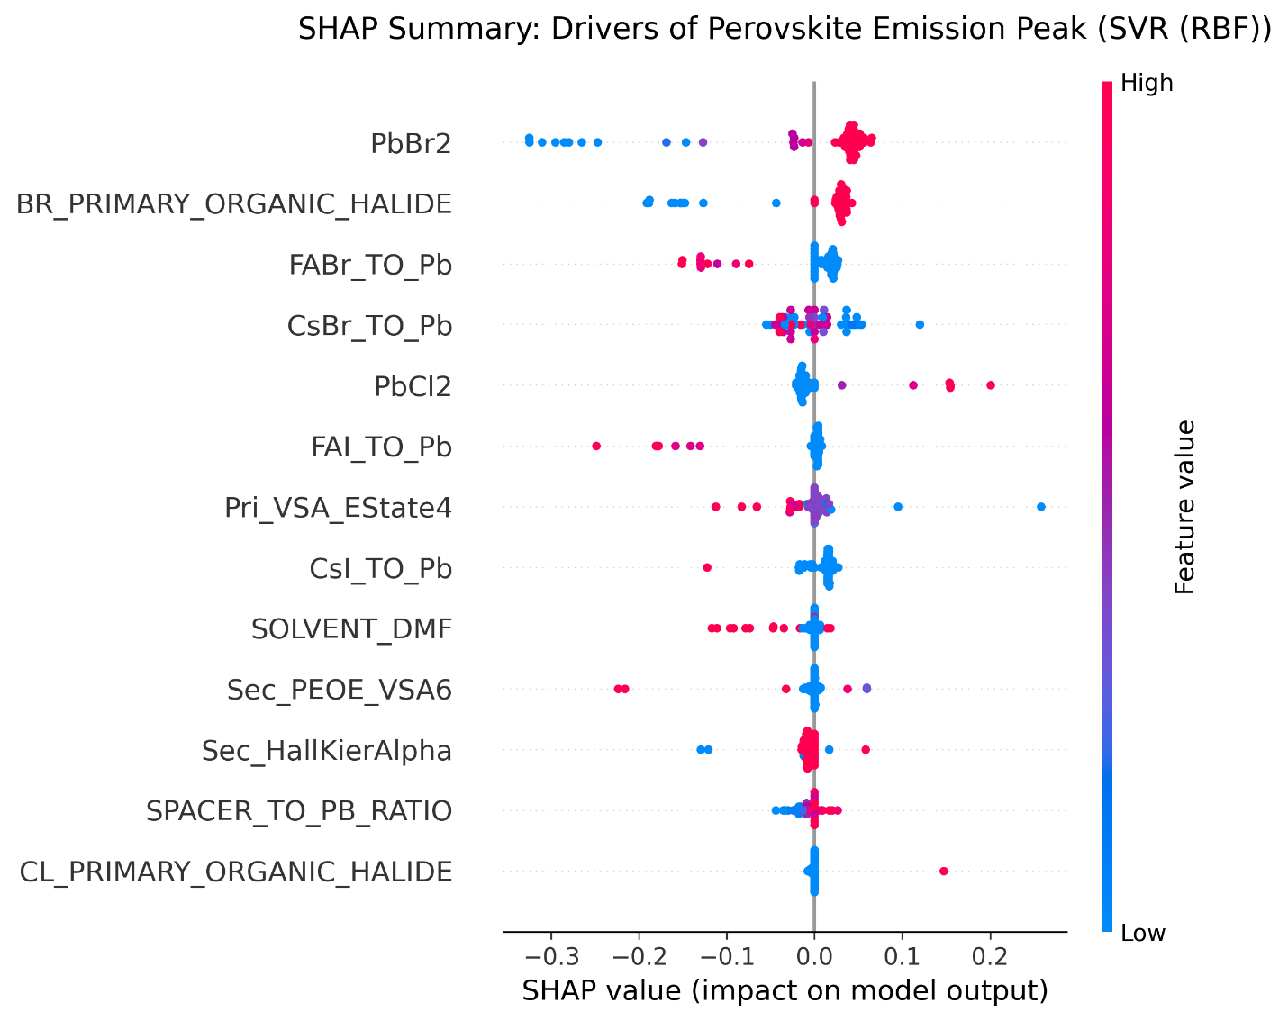
Figure 5: SHAP for the SelectFromModel feature selection based SVR model - (champion model).
Table 2. SHAP summary for hyperparameter-tuned SVR–RBF (thirteen SelectFromModel features). ⟨|φ|⟩ = mean absolute Shapley contribution (eV); share = percentage of Σ⟨|φ_{j}|⟩.
Rank | Descriptor | ⟨|φ|⟩ (eV) | Share (%) | Trend when feature ↑ | Chemical / physical mechanism
1 | PbBr₂ | 0.074 | 21.4 | hypsochromic shift (r ≈ +0.95) | Inorganic Br raises the bandgap and favours wider-gap relative to iodide-only compositions.
2 | BR_PRIMARY_ORGANIC_HALIDE | 0.059 | 17.1 | hypsochromic shift (r ≈ +0.96) | Bromide on the primary ammonium spacer increases halide incorporation on the organic site and blue-shifts the emission relative to iodide-only compositions.
3 | FAI_TO_Pb | 0.031 | 8.9 | bathochromic shift (r ≈ −0.98) | Formamidinium iodide fraction enriches iodide character and lowers the effective gap, consistent with red-shifted quasi-2D MHPs PL/EL when iodide dominates.
4 | FABr_TO_Pb | 0.028 | 8.0 | bathochromic shift (r ≈ −0.91) | FA bromide pathway competes with high-gap chloride/bromide routes; higher FA:Pb (Br) correlates with lower predicted E_{ph} according to the trend in the collected dataset.
5 | CsI_TO_Pb | 0.027 | 7.8 | bathochromic shift (r ≈ −0.87) | Caesium iodide makes the quasi-2D MHPs iodide-rich; a lower gap is expected in comparison to bromide precursor sets.
6 | PbCl₂ | 0.027 | 7.7 | hypsochromic shift (r ≈ +0.97) | Chloride in the inorganic precursor increases the chemical potential and correlates with higher reported E_{ph}.
7 | Pri_VSA_EState4 | 0.024 | 6.8 | bathochromic shift (r ≈ −0.79) | Primary-spacer VSA by electrotopological state is a proxy for heteroatom-rich headgroups that alter hydrogen bonding and interlayer spacing at the interface.
8 | CsBr_TO_Pb | 0.023 | 6.5 | Weak | CsBr fraction modulates A-site/halide balance; weaker monotonic trend because Cs appears with mixed halides in data.
9 | SOLVENT_DMF | 0.017 | 4.9 | Weak | DMF vs DMSO shifts crystallisation and phase distribution
10 | SPACER_TO_Pb_RATIO | 0.013 | 3.7 | Weak | Stoichiometry targets average n and dielectric confinement.
11 | Sec_HallKierAlpha | 0.011 | 3.3 | Weak | Secondary spacer flexibility/topology (mixed spacer case); perturbs interlayer spacing and local dielectric environment.
12 | CL_PRIMARY_ORGANIC_HALIDE | 0.008 | 2.3 | hypsochromic shift (r ≈ +0.97) | High correlation but low ⟨|φ|⟩ because fewer entries use chloride in primary recipes.
13 | Sec_PEOE_VSA6 | 0.006 | 1.7 | Weak | Partial-charge-weighted VSA on the secondary ligand; fine tunes mixed spacer systems.


Figure 6: Screenshot of the Streamlit web application UI.
2.3. Interactive Streamlit Web Application
To bridge the gap between machine learning model development and practical experimental application, we deployed our champion 13-feature SVR model as an interactive, publicly accessible web application using Streamlit Cloud. The Python code development, debugging, and optimization for the Streamlit application were assisted by Integrated Development Environments (IDEs), specifically Cursor²³ and Antigravity²⁴, through Vibe coding. While previous studies have established the theoretical feasibility of using ML to predict perovskite emission properties, they often lack user-friendly interfaces, restricting their utility to researchers with programming expertise. Our web application allows users to seamlessly input primary and secondary organic spacers via IUPAC names, SMILES strings, or a predefined dropdown list, alongside experimental processing variables and precursor molar ratios. The application automatically computes the necessary RDKit molecular descriptors in the backend and predicts the emission photon energy and corresponding wavelength, providing a visual colour badge of the expected emission. This real-time predictive capability empowers researchers to rapidly screen combinatorial precursor recipes and spacer chemistries before committing to laboratory synthesis. The application is publicly accessible at https://mlquasi2demissioneqe-8yvtmbep6kul3izkcuafzs.streamlit.app/, and a screenshot of the user interface is shown in Figure 6.
2.4. ML Models for External Quantum Efficiency Prediction: A different problem
Similar to the E_{ph} prediction model development discussed above, now to target predicting EQEs of the quasi-2D MHP LEDs, we prepared a curated dataset of 266 records extracted from the available literature (dataset available on GitHub: SF_DATA_EMISSION_PEAK.xlsx, sheet EQE_CLEANED and dataset statistics in Table S10) with hole-transport material (HTL), electron-transport material (ETL), additive, and experimental processing variables (temperature, annealing time) in addition to the compositional columns used for emission. Thirty-four distinct HTLs and thirteen ETLs are available in the dataset, while EQE spans 0.002% to 30.8%. After repeating the same workflow steps for featuring engineering used above for E_{ph} prediction models, post-recursive feature elimination to 20 descriptors, and extensive hyperparameter tuning, the best tree models achieved R² ≈ 0.44–0.51 on the test fold (Table 3). We developed a CatBoost model that treats HTL, ETL, and additive as native categorical variables to encode the correct device architecture, thereby raising R² to 0.57 and reducing RMSE ≈ to 4.4% EQE. That improvement is real but modest, which could explain a little more than half the variance in EQE, whereas the emission model explains about 95% of the variance in E_{ph} using the same split and workflow with more details. After achieving the best ML model for predicting emission colour at the materials level, one might hope EQE would follow from the same tables. Apparently, it does not happen, at least not with the details available in published PeLED reports.
Table 3. Summary of the hyperparameter-tuned models' performance in predicting the EQE.
Model | R² | RMSE (% EQE) | MAE (% EQE)
Tuned XGBoost | 0.512 | 5.01 | 3.77
Tuned random forest | 0.478 | 5.18 | 3.88
Tuned CatBoost | 0.570 | 4.42 | 3.25
The gap between the emission prediction model (R² ≈ 0.95) and the EQE prediction model (R² ≈ 0.5–0.6) is not a failure of the algorithms. Rather, there are straightforward, concrete reasons that caused this issue. EQE couples radiative efficiency to charge-injection balance and outcoupling. Pinhole-free morphology, interfacial trap passivation, refractive-index matching and the exact measurement protocol move EQE by several percentage points without changing the precursor stoichiometry. Different laboratories also anneal and antisolvent-quench under conditions that are described in prose but rarely discussed in the manuscripts. Zhang et al. illustrated that the data problem in device-targeted ML development persists even with careful molecular featurization.²² PeLED performance labels in the literature are sparse and heterogeneous, given the volume of available data. Therefore, we can expect the model’s predictions to be accurate only when the dataset is built from a single device architecture with in-house experiments, as fabrication conditions are consistent across devices. This implies that models are most trustworthy when inputs and labels refer to the same experimental context, and least trustworthy when they silently average over different fabrication routes.
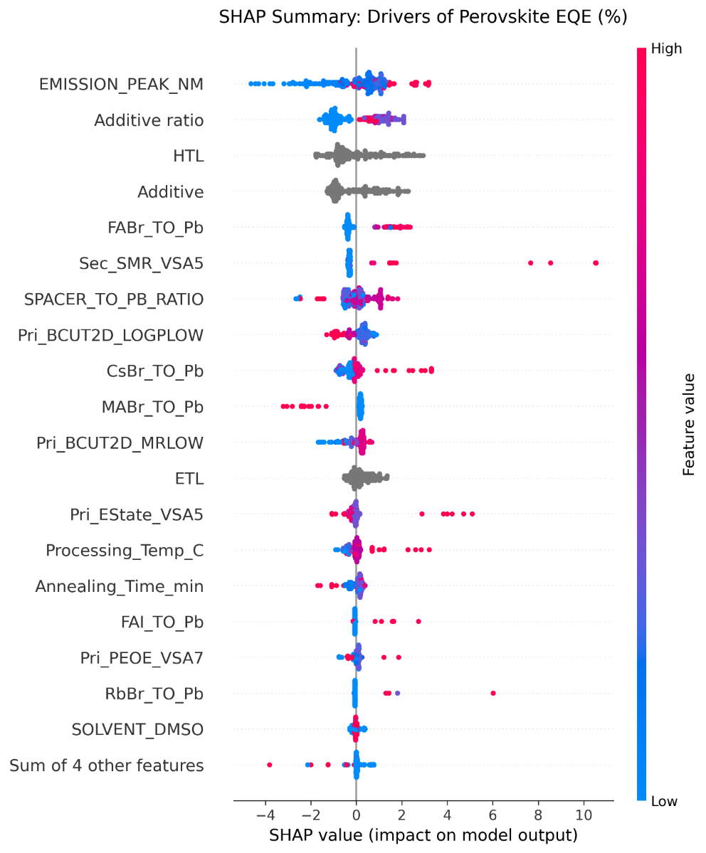
Figure 7: SHAP summary for the CatBoost EQE model.
3. Conclusions
In this work, we began by preparing two datasets from the available literature on quasi-2D MHPs, focusing on emission energy and device EQE. We then performed an initial cleanup using snowflake and pandas dataframe functions, respectively. Thereafter, molecular descriptors were generated for the organic spacers from their SMILES, and feature selection methods were applied. Finally, ML models were trained and evaluated.
Specifically, a hyperparameter-tuned SVR model utilising a feature engineered dataset of 13 variables, which include halide identity, spacer-to-lead stoichiometry, critical A-site and lead-halide fractions, DMF processing parameters, and three organic spacer topology descriptors, unambiguously outperformed a higher dimensional 31 variable RFECV feature selection routine on held-out test records. For the optimised SVR model, the 13-feature pipeline achieved a coefficient of determination (R²) of 0.953 and a low root-mean-square error (RMSE) of 0.074 eV, whereas the 31-variable RFECV channel resulted in R² of 0.920 eV for its tuned SVR variant. This performance gap reflects a fundamental statistical reality where a training dataset with 226 records is highly prone to overfitting as the number of descriptor dimensions increases. Furthermore, SHAP analysis confirms that the variables retained by our top-performing materials pipeline align cleanly with the principles of composition and quantum confinement.
On the other hand, device-level EQE are less predictable when modelled using similar literature inputs with additional device-level details, yielding a weak R² of approximately 0.5–0.6 at best. Although the integration of transport-layer features provides a modest performance benefit, physical film morphology and specific laboratory fabrication protocols and conditions determine overall efficiency, which may vary from one laboratory report to another with the same set of recipes and device architectures. These insights establish that chemically lean ML models are accurate for predicting intrinsic material properties (E_{ph}), but device-based metrics such as EQE remain fundamentally unlearnable across heterogeneous literature sources without strictly standardised fabrication and testing conditions.
Finally, to make this work practically useful for the research community, the best-performing 13-feature SVR model is deployed as a publicly accessible web UI application in Streamlit Cloud. Instead of relying on coding knowledge, users can simply enter the IUPAC name or SMILES string for their organic spacers, along with the required precursor ratios. The application then automatically calculates molecular descriptors in the background and provides a real-time emission energy prediction for the corresponding quasi-2D MHP and the molecule structure provided in the input.
ASSOCIATED CONTENT
Github link: The codebase and configuration files are available at https://github.com/ranadeeprajsumukam/ML_Quasi_2D_Emission_EQE.
Streamlit Cloud Web UI application link: https://mlquasi2demissioneqe-8yvtmbep6kul3izkcuafzs.streamlit.app/
The curated workbook is available from the corresponding author on reasonable request.
Supporting Information: Datasets statistics, cross-validation graphs, learning curve graphs, and details on all non-champion ML models and their approaches.
AUTHOR INFORMATION
Corresponding Author
*Email: murali.banavoth@uohyd.ac.in
AUTHOR CONTRIBUTIONS
Ranadeep Raj Sumukam: conceptualisation, data curation, investigation, end-to-end analysis, methodology, writing – review & editing. Ramu Naidu Savu: formal analysis, writing – review & editing. Santosh Rompivalasa: formal analysis. Murali Banavoth: funding, supervision, project administration, writing – review & editing. All authors have given approval to the final version of the manuscript.
ACKNOWLEDGMENT
This work was supported by the School of Chemistry, University of Hyderabad. RRS acknowledges the Council of Scientific and Industrial Research (CSIR) for the Senior Research Fellowship (SRF). MB acknowledges the Institute of Eminence Research grant (UOH-IOE-RC2-21-008) for funding.
CONFLICT OF INTEREST
There are no conflicts to declare.
REFERENCES
1. Hazra, V.; Mandal, A.; Bhattacharyya, S., Optoelectronic insights of lead-free layered halide perovskites. Chemical Science 2024, 15 (20), 7374-7393.
2. Sumukam, R. R.; Sahu, P.; Savu, R. N.; Khanam, S. J.; Alsulami, Q. A.; Banavoth, M., Halide Ions Distribution and Charge Dynamics in Mixed-Halide Perovskites. 2022, 16 (5), 2100576.
3. Kumar, G. S.; Sumukam, R. R.; Rajaboina, R. K.; Savu, R. N.; Srinivas, M.; Banavoth, M., Perovskite Nanowires for Next-Generation Optoelectronic Devices: Lab to Fab. ACS Applied Energy Materials 2022, 5 (2), 1342-1377.
4. Li, G.; Zhang, Z.; Agyei-Tuffour, B.; Wu, L.; Gries, T. W.; Prashanthan, K.; Frohloff, L.; Musiienko, A.; Li, J.; Zhu, R.; Hart, L. J. F.; Wang, L.; Li, Z.; Hou, B.; Koch, N.; Saba, M.; Barnes, P. R. F.; Nelson, J.; Dyson, P. J.; Nazeeruddin, M. K.; Li, M.; Abate, A., Stabilizing high-efficiency perovskite solar cells via strategic interfacial contact engineering. Nature Photonics 2026, 20 (1), 55-62.
5. Karlsson, M.; Yi, Z.; Reichert, S.; Luo, X.; Lin, W.; Zhang, Z.; Bao, C.; Zhang, R.; Bai, S.; Zheng, G.; Teng, P.; Duan, L.; Lu, Y.; Zheng, K.; Pullerits, T.; Deibel, C.; Xu, W.; Friend, R.; Gao, F., Mixed halide perovskites for spectrally stable and high-efficiency blue light-emitting diodes. Nature Communications 2021, 12 (1), 361.
6. Kumar, G. S.; Sumukam, R. R.; Murali, B., Quasi-2D perovskite emitters: a boon for efficient blue light-emitting diodes. Journal of Materials Chemistry C 2020, 8 (41), 14334-14347.
7. Zhang, J.; Yan, C.; Zhao, H.; Yin, C.; Bai, S., Modulations of Quasi-Two-Dimensional Metal Halide Perovskites toward High-Performance Blue Light-Emitting Diodes. Advanced Functional Materials 2026, 36 (22), 2509226.
8. Liu, Y.; Wang, H.; Zhang, F.; Chai, X.; Liu, K.; Zhang, S.; Kong, M.; Liu, H.; Wang, X.; Lu, M.; Yang, Y.; Wu, Z.; Zhang, Y.; Fan, C.; Bai, X., High-Efficiency and Stable Pure Bromine Blue Light-Emitting Diodes Enabled by Hybrid Quasi-2D Perovskite. Advanced Functional Materials 2026, 36 (11), e15841.
9. Zhang, G.; Tang, J.; Wu, X.; Chen, J.; Zhang, C.; Zhu, X.; Yu, H.; Shi, Y.; Wang, X.; Li, J.; Wang, K.; Li, J., Synergistic Passivation via Amino Acid Derivative for Highly Efficient Quasi-2D Perovskite Green Light-Emitting Diode. ACS Applied Materials & Interfaces 2025, 17 (20), 29864-29872.
10. Yu, A.; Wang, J.; Huo, Y.; Wang, S.; Zhang, X.; He, T.; Yang, S.; Jiang, Y.; Zhang, L.; Liu, Z.; Yuan, M.; Sun, C., Promoting Phase Transition in Quasi-2D Perovskites For High-Performance Pure-Red LEDs. Advanced Materials 2025, 37 (28), 2503704.
11. Tsai, H.; Nie, W.; Blancon, J. C.; Stoumpos, C. C.; Asadpour, R.; Harutyunyan, B.; Neukirch, A. J.; Verduzco, R.; Crochet, J. J.; Tretiak, S.; Pedesseau, L.; Even, J.; Alam, M. A.; Gupta, G.; Lou, J.; Ajayan, P. M.; Bedzyk, M. J.; Kanatzidis, M. G., High-efficiency two-dimensional Ruddlesden-Popper perovskite solar cells. Nature 2016, 536 (7616), 312-6.
12. Lu, F.; Liang, Y.; Wang, N.; Zhu, L.; Wang, J., Machine learning for perovskite optoelectronics: a review. 2024, Advanced Photonics (5), 054001.
13. de la Asunción-Nadal, V.; Iliffe Sprague, C.; Guijarro-Berdiñas, B.; Cappel, U. B.; García-Fernández, A., Machine learning for perovskite solar cells: a comprehensive review on opportunities and challenges for materials scientists. EES Solar 2025, 1 (6), 927-957.
14. Zhang, R.; Motes, B.; Tan, S.; Lu, Y.; Shih, M.-C.; Hao, Y.; Yang, K.; Srinivasan, S.; Bawendi, M. G.; Bulović, V., Machine Learning Prediction of Organic–Inorganic Halide Perovskite Solar Cell Performance from Optical Properties. ACS Energy Letters 2025, 10 (4), 1714-1724.
15. Toprak, A., Predicting photovoltaic output parameters of perovskite solar cells using explainable machine learning with physics-informed and simulation-derived descriptors. Materials Today Communications 2026, 52, 114968.
16. Wang, Z.; Chen, C.; Qian, S.; Jia, B.; Xu, Y.; Guan, X.; Han, Z.; Tuo, Y.; Du, Y.; Yun, X.; Xie, J.; Liu, G.; Lu, P., Data-Driven Design of Halide Perovskites for Efficient Green Light-Emitting Diodes via Machine Learning and DFT. The Journal of Physical Chemistry C 2025, 129 (30), 13542-13557.
17. Wang, S.; Liu, C.; Hao, W.; Zhuang, Y.; Zhu, X.; Wang, L.; Niu, X.; Liu, S.; Chen, B.; Zhao, Q., From Formability to Bandgap: Machine Learning Accelerates the Discovery and Application of Perovskite Materials. ACS Nano 2025, 19 (32), 29049-29072.
18. Wang, Y.; Liu, J.; Liu, Y.; Li, S.; Xu, X.; Lou, Z., Recent advances in lead-free halide perovskites: from synthesis to applications. Journal of Materials Chemistry C 2024, 12 (28), 10267-10329.
19. Zhang, L.; Lu, F.; Tao, G.; Li, M.; Yang, Z.; Wang, A.; Zhu, W.; Cao, Y.; Jin, Y.; Zhu, L.; Huang, W.; Wang, J., Prediction of Operational Lifetime of Perovskite Light Emitting Diodes by Machine Learning. 2024, 6 (6), 2300772.
20. Ghodeswar, U. S.; Balpande, R. S.; Raut, V. P.; Waje, M. G.; Pethe, Y. S.; Shelke, N.; Isleem, H. F.; Vairagade, V. S., The optimization of design and performance in hybrid organic/inorganic LEDs toward next-generation high-efficiency LEDs: application of multi-model hybrid machine learning approach. Journal of Computational Electronics 2025, 24 (3), 92.
21. Wang, W.; Li, Y.; Zou, A.; Shi, H.; Huang, X.; Li, Y.; Wei, D.; Qiao, B.; Zhao, S.; Xu, Z.; Song, D., Predicting the photon energy of quasi-2D lead halide perovskites from the precursor composition through machine learning. Nanoscale Advances 2022, 4 (6), 1632-1638.
22. Zhang, L.; Li, N.; Liu, D.; Tao, G.; Xu, W.; Li, M.; Chu, Y.; Cao, C.; Lu, F.; Hao, C.; Zhang, J.; Cao, Y.; Gao, F.; Wang, N.; Zhu, L.; Huang, W.; Wang, J., Deep Learning for Additive Screening in Perovskite Light-Emitting Diodes. 2022, 61 (37), e202209337.
23. Cursor IDE, version 3.13.21; Anysphere: San Francisco, CA, 2026. Available from: https://www.cursor.com.
24. Antigravity IDE, version 2.5.5; Google DeepMind: London, UK, 2026.

